**1. Triangle / Pyramid**   
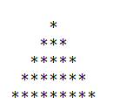

**2. Inverted pyramid**   
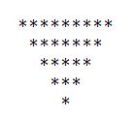

**3. Hollow Diamond**   
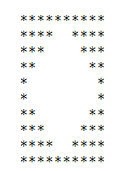

**4. Diamond**   
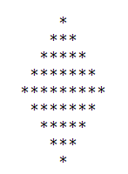

**5. Right angle Triangle**   
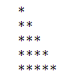

**6. Inverted Right angle Triangle**   
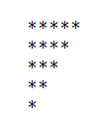

**7. Mirrored inverted Right angle Triangle**   
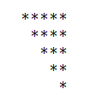

**8. Hollow Diamond 2**   
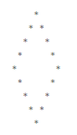

**9. Inverted Pyramid**   
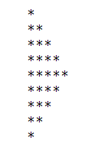

**10. Right arrow**   
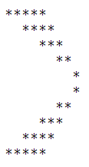

**11. Rhombus**   
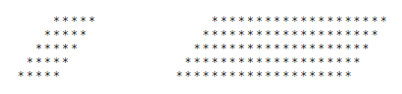

**12. Hollow Rhombus**   
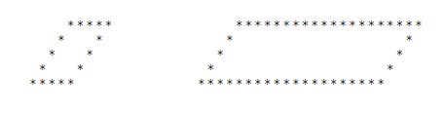

**13. Mirrored Rhombus**   
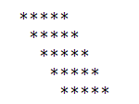

**14. Hollow Mirrored Rhombus**   
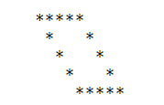

**15. Hollow right angle triangle**   
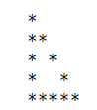

**16. Hollow Inverted Pyramid**   
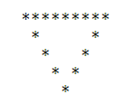

**17.  Mirrored Inverted Pyramid**   
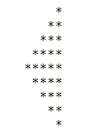

**18. Left arrow**   
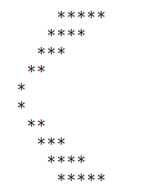

19. Print the following Pattern (N=5) 20. Print the following Pattern (N=5)

ABCDEDCBA 1

ABCD DCBA 01

ABC CBA 101

AB BA 0101

A A 10101